|  |  |
| --- | --- |
|  | SQE Project |
|  |  |
|  | Kashmala Ahmad  Alishba Shabbir  SE-5B |

Contents

**Testim Documentation Overview** 7

**Testim Overview** 7

**1. Introduction to Testim** 7

**Key Features:** 7

**2. Key Features of Testim** 7

**Feature Overview Table** 7

**3. Detailed Descriptions of Key Features** 8

**Fast Authoring** 8

**AI-Based Stabilization** 8

**Cross-Browser Testing** 8

**Customizable Reports** 8

**Smart Locators** 8

**Test Parameterization** 8

**Collaboration Tools** 8

**4.ScreenShots:** 9

Test Cases: 9

9

Properties: 10

Menu Bar: 10

10

11

**5. Learning Resources and Tutorials** 11

**Video Tutorials:** 11

**Written Guide:** 11

• testim-overview 11

• test-automation 11

Overview of Test Automation Platforms 11

1. Introduction to TestSigma 11

2. Key Features of TestSigma 12

3. Detailed Descriptions of Key Features 12

Introduction to TestRigor 13

Key Features: 13

Key Features of TestRigor 13

Detailed Descriptions of Key Features 14

ScreenShots: 15

15

16

16

17

Introduction to Mabl 17

2. Key Features of Mabl 17

3. Detailed Descriptions of Key Features 18

**Testim Documentation Overview**

**Testim Overview**

**Testim** is a powerful tool for automating the testing of web applications. It leverages **artificial intelligence** to enhance the efficiency and effectiveness of the testing process. Below is a detailed overview of Testim and its features.

**1. Introduction to Testim**

**Testim** is an AI-powered test automation platform designed to help teams quickly create, execute, and maintain automated tests. It supports the entire testing lifecycle, from authoring to execution and maintenance, using AI to optimize and stabilize tests.

**Key Features:**

* **AI-Powered**: Uses machine learning to improve test stability.
* **Fast Authoring**: Quickly create tests using a visual editor or code.
* **Flexible Execution**: Run tests in the cloud or on-premises.
* **Detailed Reporting**: Provides in-depth reports and insights.

**2. Key Features of Testim**

**Feature Overview Table**

|  |  |
| --- | --- |
| **Feature** | **Description** |
| **Fast Authoring** | Create tests using a visual editor, ensuring quick and easy test development. |
| **AI-Based Stabilization** | Uses AI to identify and fix unstable tests, reducing false positives and maintenance efforts. |
| **Cross-Browser Testing** | Supports testing across multiple browsers to ensure compatibility and functionality. |
| **Customizable Reports** | Generate detailed and customizable reports for better insights and decision-making. |
| **CI/CD Integration** | Seamlessly integrates with CI/CD pipelines for continuous testing and deployment. |
| **Smart Locators** | Uses dynamic locators to identify UI elements, making tests more robust. |
| **Test Parameterization** | Allows parameterization of tests to run them with different data sets. |
| **Collaboration Tools** | Facilitates collaboration among team members with shared test cases and results. |

**3. Detailed Descriptions of Key Features**

**Fast Authoring**

Testim provides a user-friendly visual editor that allows testers to quickly create automated tests without the need for extensive coding knowledge. The platform also supports code-based test creation for more advanced users.

**AI-Based Stabilization**

Testim’s AI algorithms continuously analyze tests to identify patterns and stabilize tests by adjusting them based on historical data. This reduces the likelihood of test flakiness and ensures reliable test results.

**Cross-Browser Testing**

Testim supports running tests on various browsers, including Chrome, Firefox, Safari, and Edge. This ensures that web applications function correctly across different environments.

**Customizable Reports**

The platform provides detailed and customizable reports that highlight test results, failures, and performance metrics. These reports help teams quickly identify issues and understand test coverage.

**Smart Locators**

Testim uses AI-powered smart locators to identify UI elements. These locators adapt to changes in the application’s UI, making tests more resilient to changes and reducing maintenance efforts.

**Test Parameterization**

Testim allows testers to parameterize tests, enabling them to run the same test with different sets of data. This feature is useful for testing various scenarios and data combinations.

**Collaboration Tools**

Testim includes features that facilitate collaboration among team members. Test cases and results can be shared, and team members can leave comments and feedback, improving communication and efficiency.

**4.ScreenShots:**

### Test Cases:

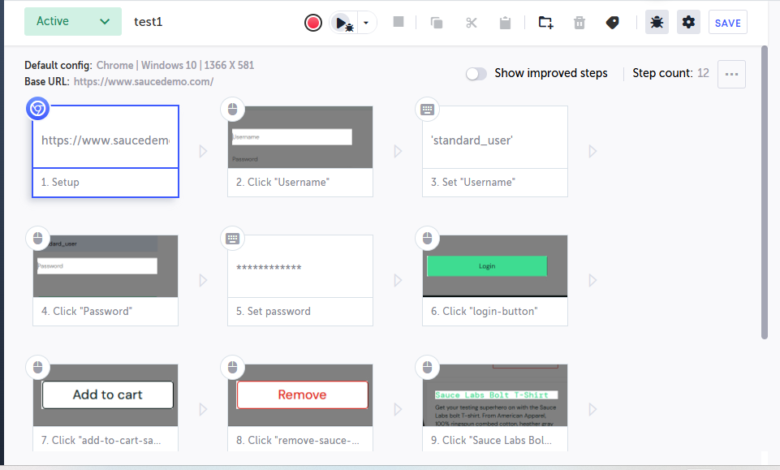

### Properties:

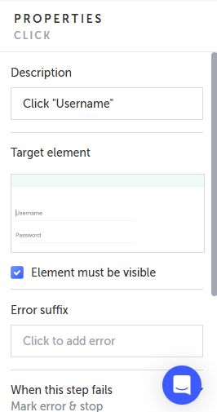

### Menu Bar:



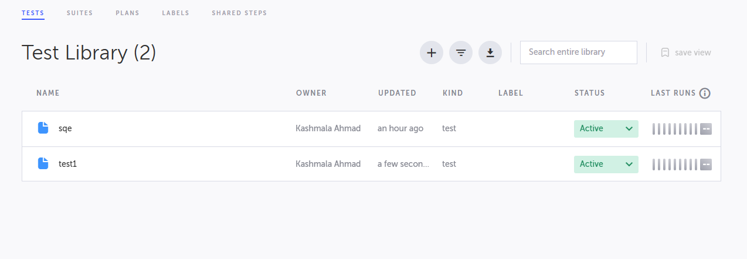

**5. Learning Resources and Tutorials**

**Video Tutorials:**

* [Introduction to Testim](https://youtu.be/duGCopo0bko?si=kEXA3a5r1rmkO7yc)
* [Tutorial](https://www.youtube.com/watch?v=hy2FoW70doI&list=PLhW3qG5bs-L-Fgaw6V6uRVL-oyv0dUSCm&form=MG0AV3)

**Written Guide:**

* [testim-overview](https://help.testim.io/docs/testim-overview)
* [test-automation](https://www.testim.io/blog/what-is-test-automation/)

## Introduction to TestRigor

**TestRigor** is a low-code test automation platform that uses AI to streamline test creation, execution, and maintenance. It leverages machine learning to analyze test behavior and optimize tests for stability. With TestRigor, teams can rapidly generate tests without extensive coding, allowing them to focus more on **quality** rather than the complexity of automation.

### ****Key Features****:

* **Low-Code Test Authoring**: Create tests without writing complex code.
* **AI-Driven Test Stabilization**: Uses AI to enhance test stability and reduce flakiness.
* **Cross-Platform Testing**: Supports web, mobile, and API testing.
* **Visual Test Creation**: Intuitive UI for easily building and editing tests.
* **Data-Driven Testing**: Allows for testing with different data sets.
* **CI/CD Integration**: Integrates seamlessly into CI/CD pipelines.
* **Detailed Reporting**: In-depth test execution reports with real-time insights.

### ****Key Features of TestRigor****

| **Feature** | **Description** |
| --- | --- |
| **Low-Code Test Authoring** | Create tests without writing extensive code, making automation accessible to non-developers. |
| **AI-Driven Test Stabilization** | AI-powered stabilization of tests to minimize flaky tests and false positives. |
| **Cross-Platform Testing** | Supports testing for web, mobile, and API platforms. |
| **Visual Test Creation** | Easy-to-use interface for creating and editing tests visually. |
| **Data-Driven Testing** | Enables tests to run with multiple data sets for comprehensive coverage. |
| **CI/CD Integration** | Easily integrates with CI/CD tools for continuous integration and delivery. |
| **Detailed Reporting** | Provides real-time, detailed reports with test status and analytics. |

### ****Detailed Descriptions of Key Features****

#### **Low-Code Test Authoring**

TestRigor allows users to write automated tests with minimal coding, empowering testers and business teams to contribute to test creation.

#### **AI-Driven Test Stabilization**

The platform uses machine learning to analyze test behavior, identifying and resolving flaky tests, which helps ensure consistent and reliable results.

#### **Cross-Platform Testing**

TestRigor supports testing across multiple platforms including web browsers, mobile devices, and APIs, allowing for comprehensive testing coverage.

#### **Visual Test Creation**

The intuitive visual editor simplifies the process of creating tests, making it accessible for users with little technical expertise.

#### **Data-Driven Testing**

TestRigor allows tests to be executed with different sets of data, helping to verify the application’s behavior across a variety of input conditions.

#### **CI/CD Integration**

TestRigor integrates with popular CI/CD tools, allowing automated tests to run in real time as part of the development process.

#### **Detailed Reporting**

The platform provides real-time reports with detailed execution results, performance metrics, and insights that help teams monitor progress and identify issues quickly.

### ScreenShots:

### 

### 

### 

### 

### 

## ****Introduction to Mabl****

Mabl is an AI-driven test automation platform that focuses on making testing smarter and more efficient by automating test creation, execution, and maintenance. It uses machine learning to continuously learn from the application and improve the tests over time, resulting in highly stable and reliable automated tests.

#### **Key Features**:

* **AI-Powered Test Creation**: Automatically generates tests based on user interactions and application changes.
* **Self-Healing Tests**: Automatically adjusts tests to changes in the UI, reducing maintenance efforts.
* **Cross-Browser Testing**: Supports a wide range of browsers and platforms for comprehensive testing.
* **Integrations with CI/CD**: Easily integrates into CI/CD workflows for continuous testing.
* **Detailed Analytics and Reporting**: Offers insights and analytics into test results and application performance.
* **Collaboration and Sharing**: Facilitates team collaboration with shared test cases, reports, and feedback.

|  |  |  |  |  |  |  |  |  |  |  |  |  |  |  |  |
| --- | --- | --- | --- | --- | --- | --- | --- | --- | --- | --- | --- | --- | --- | --- | --- |
| 2. ****Key Features of Mabl****  | **Feature** | **Description** | | --- | --- | | **AI-Powered Test Creation** | Automatically generates tests based on application behavior and changes. | | **Self-Healing Tests** | Uses machine learning to adapt tests to UI changes automatically. | | **Cross-Browser Testing** | Supports testing on various browsers and devices. | | **Integrations with CI/CD** | Seamlessly integrates with popular CI/CD tools for continuous testing. | | **Detailed Analytics and Reporting** | Provides insights into test execution and application performance. | | **Collaboration and Sharing** | Enables team collaboration with shared test cases, results, and feedback. |  3. ****Detailed Descriptions of Key Features******AI-Powered Test Creation** Mabl uses machine learning to automatically generate tests by learning from user interactions and application changes, reducing the need for manual test creation. **Self-Healing Tests** The platform automatically adjusts tests to accommodate UI changes, ensuring that tests remain stable even when the application undergoes changes. **Cross-Browser Testing** Mabl supports testing across different browsers and devices, ensuring that web applications are compatible with various environments. **Integrations with CI/CD** Mabl integrates seamlessly with CI/CD tools to enable continuous testing and faster feedback on application changes. **Detailed Analytics and Reporting** Mabl provides detailed analytics and insights into test results, helping teams quickly identify performance issues and improve test coverage. **Collaboration and Sharing** Mabl allows team members to collaborate by sharing test cases, results, and providing feedback to streamline communication and improve testing efficiency. Screenshots: |  |

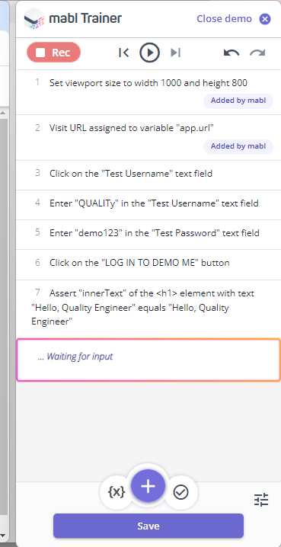

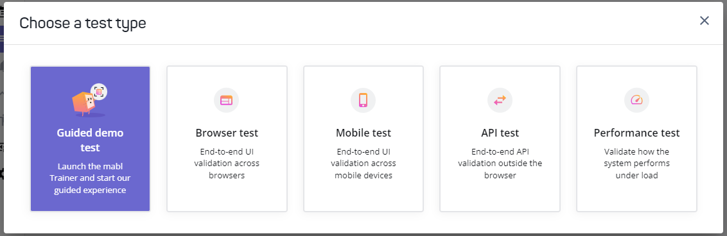

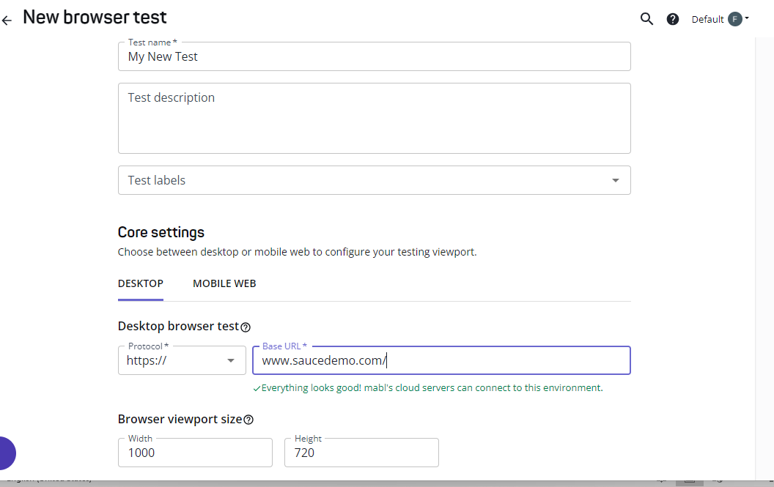

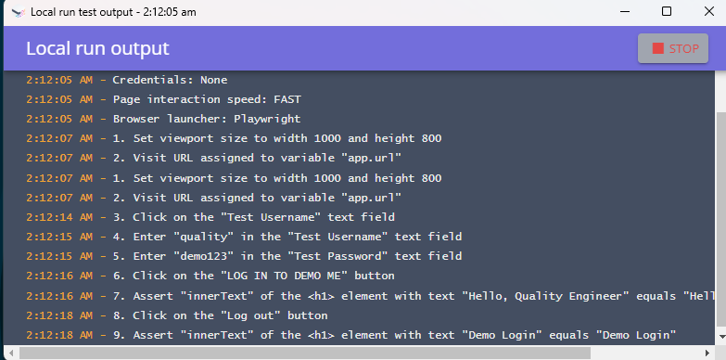

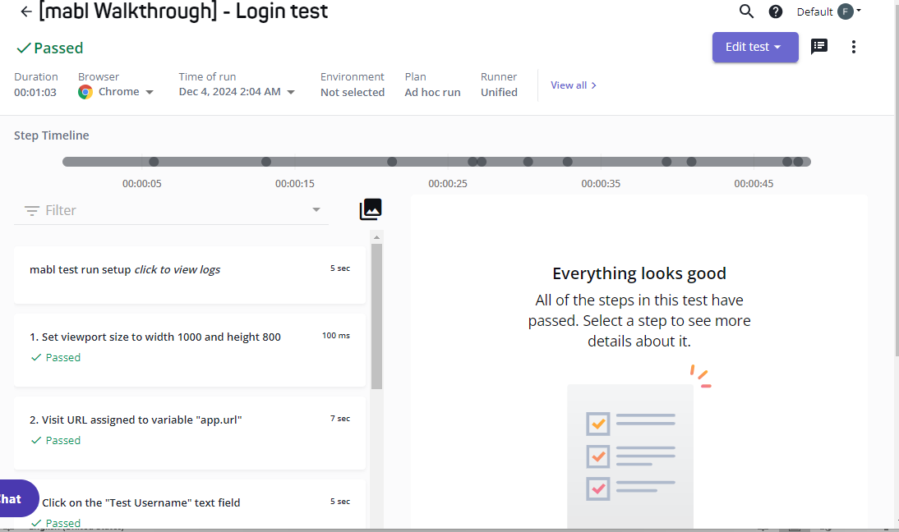

## ****Introduction to TestSigma****

**TestSigma** is an AI-powered test automation platform that focuses on delivering a collaborative and comprehensive solution for continuous testing. It integrates easily with CI/CD pipelines and provides a unified environment for teams to write, execute, and maintain automated tests. TestSigma promotes collaboration between developers, testers, and business teams by using a simple English-like language for writing tests.

#### **Key Features**:

* **Natural Language Test Authoring**: Write tests using simple, plain English language.
* **AI-Powered Maintenance**: Automatic identification and stabilization of flaky tests.
* **Cross-Browser and Mobile Testing**: Test across web and mobile platforms.
* **Advanced Reporting and Analytics**: Detailed and customizable reports for deeper insights.
* **CI/CD Integration**: Seamless integration with various CI/CD tools for continuous testing.
* **Collaborative Testing**: Tools for team collaboration on test cases and results.
* **Automated Test Data Management**: Automatic creation and management of test data.

### 2. ****Key Features of TestSigma****

| **Feature** | **Description** |
| --- | --- |
| **Natural Language Test Authoring** | Enables easy creation of tests using plain English language, making it accessible for non-technical users. |
| **AI-Powered Maintenance** | Automatically identifies and resolves flaky tests to ensure stable testing. |
| **Cross-Browser and Mobile Testing** | Supports web and mobile testing across different browsers and devices. |
| **Advanced Reporting and Analytics** | Provides detailed, customizable test reports to track performance and uncover trends. |
| **CI/CD Integration** | Integrates smoothly with popular CI/CD tools like Jenkins, GitLab, and others for continuous testing. |
| **Collaborative Testing** | Facilitates team collaboration through shared test cases and comments. |
| **Automated Test Data Management** | Simplifies the creation and management of test data for different test scenarios. |

### 3. ****Detailed Descriptions of Key Features****

#### **Natural Language Test Authoring**

TestSigma allows users to write test cases in plain English, reducing the learning curve for testers and enabling team members from non-technical backgrounds to contribute to test creation.

#### **AI-Powered Maintenance**

The platform uses AI to detect and stabilize flaky tests. It proactively adjusts tests when necessary, reducing the manual effort needed for test maintenance and ensuring consistency.

#### **Cross-Browser and Mobile Testing**

TestSigma supports testing on a wide range of browsers and mobile devices, ensuring that applications are thoroughly tested in diverse environments.

#### **Advanced Reporting and Analytics**

TestSigma provides highly customizable reports with detailed information about test execution, failures, and performance trends, helping teams quickly identify issues and make data-driven decisions.

#### **CI/CD Integration**

TestSigma integrates easily into CI/CD pipelines, allowing automated tests to run as part of the build process, ensuring continuous validation throughout the software development lifecycle.

#### **Collaborative Testing**

Collaboration features in TestSigma help teams work together by sharing test cases, leaving feedback, and reviewing results, improving efficiency and communication.

#### **Automated Test Data Management**

The platform automatically generates and manages test data, reducing the need for manual data setup and enabling tests to be executed with various data sets.